Safe Ride: The New Wave of Taxis
Robert Mines
American Military University
March 19, 2017

Safe Ride: The New Wave of Taxis
Executive Summary
Safe Ride is a mobile application designed to enable people who are unable to drive to get a ride and their car to be driven to their homes. The app will be launched nationwide and will available in all cities. The main idea behind the mobile app is to assist individuals to get home safely while providing some earnings to the driver. The target audience includes regular drinkers who may be too intoxicated to drive safely. The customers may find the app to be useful as it has additional options of taking them and their car home.
Overview
Safe Ride app will connect people unable to drive their cars with available drivers that can get them home. Users with the applications will request a driver near their allocation. Drivers requested by the users will be notified the location of the user. Customers will pay via the app and will be billed based on time spent by the driver.
The mobile app will run on multiple platforms including iOS, Windows, Blackberry, and Android. The customers will incorporate various features that support customer transactions and user interaction. It will be designed to provide a powerful user interface that responds to user needs, reflects the brand, and provide a good navigation experience.
Scope
Upfront planning in mobile app development is essential to develop appealing and successful mobile apps (Nerur, 2007). The first phase of development involves outlining a plan on how the app will work.
Use-case scenario
The audience of this mobile app is primarily the people who are unable to drive themselves home safely. This may include people who have physical conditions that limit their capability to drive or people who are too intoxicated to drive their cars safely. The individuals seek to get home safely with their cars. Drivers can help to drive the customers to their homes and deliver their cars safely. With the application, users request a driver who can drive them home. The app reduces drunk driving and accidents as intoxicated people will request the service instead of endangering themselves and others.
Wireframes
The wireframes show the outline of the mobile app and provide a blueprint that will be used to develop the app (Kollmann, 2009).
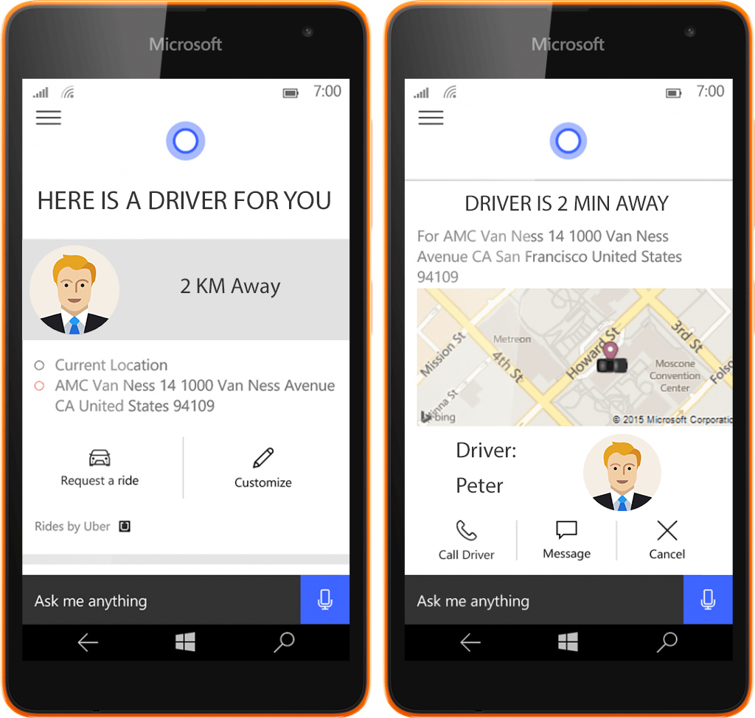

Development Phase
During development, a set of procedures will be followed to ensure the mobile is successfully completed.
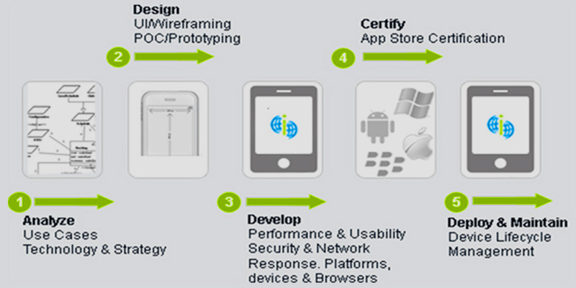
1. The project manager will oversee the development activities and facilitate communication. The manager will assign staffing resources to the development plan. The key project members include mobile developers, UI/UX expert, quality tester, and system engineers.
2. Group will focus on resolving IT issues encountered and provide recommendations on hardware, data, project scope, team objectives, and app security.
3. The project manager will develop a documentation of the work performed in the project.
4. The project manager will utilize open source third-party resources that may be required in the project to prevent licensing problems.

Features
Safe Ride will incorporate features designed to provide functionality supporting the objectives of the app. The features include:
- GPS directions that give drivers the location of the customer
- Referral feature that gives customers discounts for inviting other users
- Calling feature that allows users and drivers to communicate with each other
- Social media sharing feature that lets users share the app over Facebook and Twitter.
- Map features that allow users to indicate their destination
- Menu feature that allows users to navigate the app
- Driver rating feature that allows users to rate drivers based on their experience
- Contact information that allows customers to have multiple ways of contacting the drivers
- A fan wall that allows users to provide feedback and testimonials
- Driver listing feature that allows users to identify some of the top rated drivers
- Payment feature that allows to pay and tip the drivers through the app via PayPal
- Calculator feature to assist customers in calculating the trip costs
- Notification feature that notifies the users of new messages or events
Development Phase
The development phase of the mobile app includes mobile design, coding, and testing activities (Cohen, 2010). Quality time will be spent in this phase to ensure the app is effectively planned and subsequent phases of the project are well organized. Communication in the project team will be maintained until testing phase to ensure all the requirements are addressed. It will be essential to test the mobile app to ensure all bugs are resolved and the app functions as expected.
Objectives and Schedule
Our objectives are to:
- Develop a fully functional mobile app
- Incorporate multiple payments methods into the app
- Build an appealing user interface that makes the app compelling
- Address the needs of the target audience in the app
Phase | Week
Research | 1
Develop Wireframes | 2
Develop Mockups | 2
Coding | 3
Testing | 1
Deployment | 1

Execution and Metrics
Activities to accomplish the objectives established for the mobile app will be defined and executed. The objectives include metrics to assess the success of app development app activities in achieving the goals set. The development phase will involve:
• Overseeing development activities to enhance efficiency
• Creating a strategy
• Planning app development process
• Integrating app components

References
Cohen, S., Dori, D., & de Haan, U. (2010). A software system development life cycle model for improved stakeholders’ communication and collaboration. International Journal of Computers Communications & Control, 5(1), 20-41.
Kollmann, J., Sharp, H., & Blandford, A. (2009, August). The importance of identity and vision to user experience designers on agile projects. In Agile Conference, 2009. AGILE'09. (pp. 11-18). IEEE.
Nerur, S., & Balijepally, V. (2007). Theoretical reflections on agile development methodologies. Communications of the ACM, 50(3), 79-83.

